Nepal College of Information Technology
Assessment
Spring 2011
Program : BE Time : 3 hrs
Semester : Spring (VIII) FM : 100
Subject : Artificial Intelligence
- Candidates are requested to give their answer as far as practicable in their own words.
- The figure in the margin indicates the full marks
- Attempt ALL question

 | - Define the term “Intelligence”. What do you mean by system that thinks rationally and acts rationally? Explain with examples.  - Solve the following crypto-arithmetic problem.  E A T + T H A T = A P P L E | 2+5  8
 | - The missionaries and cannibals problem is usually stated as follows. “Three missionaries and three cannibals are on one side of a river, along with a boat that can hold one or two people. Find a way to get everyone to the other side, without ever leaving a group of missionaries outnumbered by cannibals.”  - Formulate the problem precisely  - Define operator which can be applied.  - What is quickest way to accomplish their mission?  - Explain alpha beta pruning with proper example. Why is it important? | 8  5+2
 | - Define the following terms with appropriate example: Modus Ponens, Tautology, well form formula (wwf).  - In the figure below, how would you reach to Bucharest from Arad by using A* search? Use heuristic function f(n) = g(n) + h(n), where g(n), the cost to reach the node n and h(n), the cost to get from node n to goal node. Use straight line distance as heuristic (h_{SLD}) which is provided in right side of figure. | 7  8
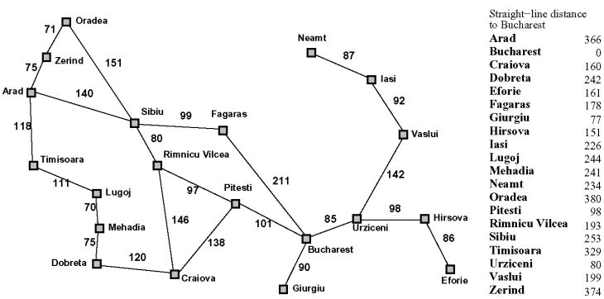
 | - Assume the following facts.  Marcus was a man. Marcus was a Pompeian. All Pompeians were Romans. Caesar was a ruler. All Pompeians were either loyal to Caesar or hated him. Everyone is loyal to someone. People only try to assassinate rulers they are not loyal to. Marcus tried to assassinate Caesar.  - Use resolution to prove “Marcus hate Caesar”  - Compare between supervised and unsupervised learning. | 10  5
 | - Explain frame with appropriate example.  - Explain multilayer feed forward neural network with necessary diagram. | 7  8
 | - Describe rule based expert system with appropriate example.  - What are the steps in the process of NLP? Describe any two with examples. | 7  8
 | Write short notes on: (Any Two)  - Existential and Universal quantifier  - Baye's Network  - Production system | 5×2

Marks Distribution According to the Unit and Credit Hours

Unit | Subtopic | Credit Hours | Question No | Marks of Question | Total
1 |  | 4 | 1(a) | 7 | 7
2 |  | 6 | 1(b), 2(a), 7(b) | 8+8+5 | 21
3 |  | 9 | 2(b), 3(b), | 7+8 | 15
4 |  | 12 | 3(a), 4(a), 4(b), 7(a) | 8+10+5+5 | 28
5 |  | 4 | 5(a) | 7 | 7
6 |  | 4 | 5(b), 6(b) | 8+8 | 16
7 |  | 6 | 6(a), 7(c) | 7+5 | 12

Marks Distribution According to the Unit and Credit Hours

Unit | Subtopic | Credit Hours | Question No | Marks of Question | Total
1 |  | 4 | 1(a) | 7 | 7
2 |  | 6 | 1(b), 2(a), 7(b) | 8+8+5 | 21
3 |  | 9 | 2(b), 3(b), | 7+8 | 15
4 |  | 12 | 3(a), 4(a), 4(b), 7(a) | 8+10+5+5 | 28
5 |  | 4 | 5(a) | 7 | 7
6 |  | 4 | 5(b), 6(b) | 8+8 | 16
7 |  | 6 | 6(a), 7(c) | 7+5 | 12

